 | Sinhgad Technical Education Society’s  RMD Sinhgad School of Engineering, Warje, Pune.  Department of Electronics & Telecommunication Engineering.

Name of Student | Aditya Ravindra Ghayal
Division | A
Roll Number | 23
Experiment Title | Link-Budget analysis
Marks

 | Sinhgad Technical Education Society’s  RMD Sinhgad School of Engineering, Warje, Pune.  Department of E&TC Engineering | Expt. No.  4
Title | Link-Budget analysis

Aim
Perform a Link-Budget analysis for a wireless communication system.

Apparatus
PC, Octave

Theory
The increased popularity of short-range wireless in home, building and industrial applications with 2.4 GHz band requires the system designers to understand the methods, estimation, cost and trade-off in short range wireless communication. Apart from considering the range estimation formula, it is good to understand the wireless channel and propagation environment involved with 2.4 GHz. Generally, RF/wireless engineers perform a link budget while starting an RF design. The link budget considers range, transmit power, receiver sensitivity, antenna gains, frequency, reliability, propagation medium (which includes the principles of physics linked to reflection, diffraction and scattering of electromagnetic waves), and environment factors to accurately calculate the performance of a 2.4 GHz RF radio link.
An account of all the various gains and losses between the transmitter and the receiver is referred to as the link budget. The system factors involved in this accounting are illustrated in following figure.
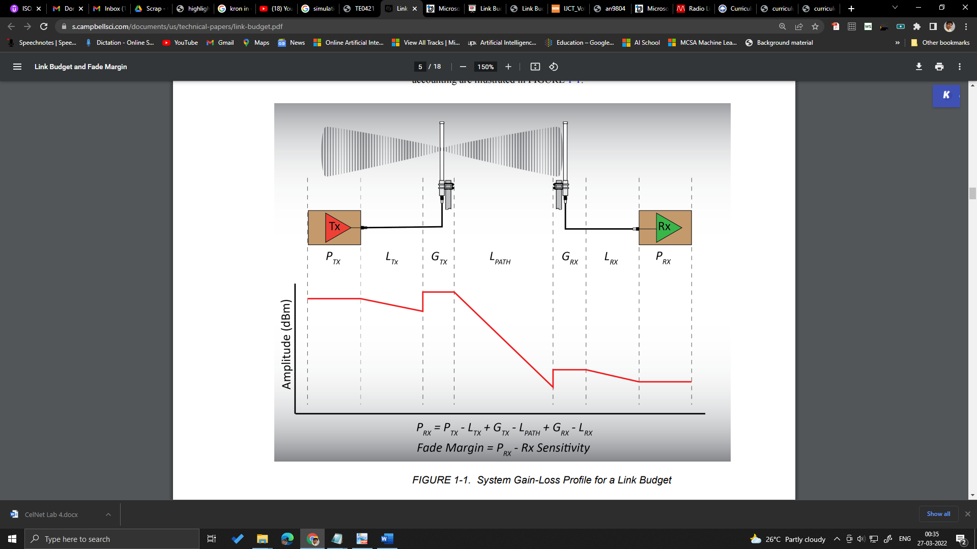
Figure: System Gain-Loss Profile for a Link Budget
Link budget is the accounting of all gains and losses from the transmitter (TX) through the medium (free space) to the receiver (RX) in a wireless communication system. Link budget considers the parameters that decide the signal strength reaching the receiver. The factors such as antenna gain levels, radio TX power levels and receiver sensitivity figures must be determined to analyze and estimate the link budget. The following parameters are considered to perform the basic link budget:
- Transmitter power
- Antenna gains (related to TX and RX)
- Antenna feed losses (related to TX and RX)
- Antenna type and sizes
- Path losses
Several secondary factors which are directly or indirectly responsible for link budget are as follows:
- Receiver sensitivity (this is not part of the actual link budget, but this threshold is necessary to decide the received signal capability)
- Required range
- Available bandwidth
- Data rates
- Protocols
- Interference and Interoperability
A link budget is an accounting of all of the power gains and losses that a communication signal experiences in a telecommunication system; from a transmitter, through a communication medium such as radio waves, cable, waveguide, or optical fiber, to the receiver. It is an equation giving the received power from the transmitter power, after the attenuation of the transmitted signal due to propagation, as well as the antenna gains and feedline and other losses, and amplification of the signal in the receiver or any repeaters it passes through. A link budget is a design aid, calculated during the design of a communication system to determine the received power, to ensure that the information is received intelligibly with an adequate signal-to-noise ratio. Randomly varying channel gains such as fading are taken into account by adding some margin depending on the anticipated severity of its effects. The amount of margin required can be reduced by the use of mitigating techniques such as antenna diversity or frequency hopping.
A simple link budget equation looks like this:
$$Received power (dBm) = transmitted power (dBm) + gains (dB) - losses (dB)$$
Power levels are expressed in (dBm), Power gains and losses are expressed in decibels (dB), which is a logarithmic measurement, so adding decibels is equivalent to multiplying the actual power ratios.
In wireless communication, a good range is usually obtained from the Free Space Path Loss (FSPL). FSPL is the loss in signal strength of an electromagnetic wave due to the Line of Sight (LOS) path through the free space with no obstacles near the source of the signal to cause reflection or diffraction. Path loss (or path attenuation) is the reduction in power density (attenuation) of an electromagnetic wave as it propagates through free space.
Path loss is caused by free space loss, refraction, diffraction, reflection and absorption, or all of these. It is also influenced by the terrain types, environment (urban or rural, vegetation and flora), propagation medium (moist or dry air), distance between the TX and RX, and antenna height and location. Path loss is unaffected by the factors such as antenna gains of TX and RX, and the loss associated with hardware imperfections. The FSPL is dominant in an outdoor LOS environment, where the antenna is placed far from the ground and with no obstructions.
The path loss formula calculates the FSPL, and these calculations are compared to actual measurements specified in Range Measurement Conditions and Results. When the antennas are assumed to have unity gain, the path loss formula reduces to following equation. The free space model is only valid for distances that are in the far field region of the transmitting antenna.
$$PathLoss \left(dB\right) = 20 ×\log\left(f\right)+ 20×\log\left(d\right) + 32.44 dB$$
where, f = Frequency (MHz) d = Distance (km)
For above equation in free space (ideal transmission channel), the path loss is calculated when loss coefficient is 2. When the transmission channel is nonideal, the typical path loss coefficient values are 2.05 to 2.5 for LOS and 3.0 to 4.0 for indoor/non-LOS environments. The non-ideal characteristics of the transmission channel result in the transmitting wave producing reflection, diffraction, absorption and scattering. In an indoor environment, many obstructions may add constructively or destructively for the radio wave propagations. For example, part of the wave energy is transmitted or absorbed into the obstruction, and the remaining wave energy is reflected off the medium's surface.
Also, the RF wave energy is a function of the geometry and material properties of the obstruction, phase, amplitude and polarization of the incident wave. Reflection occurs when electromagnetic (RF) wave strikes upon an obstruction with very large dimension compared to the wavelength of the radio wave during propagation. Reflections from the surface of the earth and from buildings produce reflected waves that may interfere constructively or destructively at the receiver point. Diffraction occurs when the radio transmission path between the TX and RX is obstructed by sharp edges. Based on Huygen’s principle, secondary waves are formed behind the obstructing body even though it is not LOS between the TX and RX. RF waves travelling in urban and rural area (non-LOS) are due to Diffraction. This phenomenon is also called Shadowing, because the diffracted field can reach a receiver even when it is shadowed by thick obstruction.
Similar to reflection, diffraction is affected by the physical properties of the obstruction and the incident wave characteristics. When the receiver is heavily obstructed, the diffracted waves may have sufficient strength to produce a useful signal. Scattering occurs when the radio channel contains objects with dimensions that are in the order of the wavelength or less of the propagating wave. Scattering almost follows the same physical principles as diffraction and causes energy from a TX to be radiated again in different directions. Scattering also occurs when the transmitted wave encounters a large quantity of small dimension objects such as lamp posts, bushes and trees. The reflected energy in a scattering situation is spread in all directions. Analysing and predicting the scattered waves is the most difficult of the three propagation mechanisms in wireless communication.
Generally, the obstructed path loss is more difficult to analyse, especially for different indoor scenarios and materials. Hence, different path loss models exist to describe unique and dominant indoor characteristics, such as multi-level buildings with windows and single level buildings without windows. The attenuation decreases floor wise with the increase in the number of floors. This phenomenon is caused by diffraction of the radio waves along the side of a building as the radio waves penetrate the building's windows. However, this is apart from the average signal loss for radio path obstruction by different materials and Floor Attenuation Factor (FAF) for signal penetration across multiple floors. Also, different indoor configurations can be categorized for buildings with enclosed offices or office spaces consisting of a mix of cubicles and enclosed rooms.

 | Sinhgad Technical Education Society’s  RMD Sinhgad School of Engineering, Warje, Pune.  Department of E&TC Engineering | Expt. No.  4
Title | Link-Budget analysis
 | Student Worksheet

Problem Statement
For a wireless communication system, following parameters are prescribed.
- Operating frequency = 12 GHz
- Transmit Power = 6W
- Transmitting antenna gain = 48.2 dB
- Receiving antenna gain = 50 dB
- Distance between transmitting and receiving antenna = 50 km
- Receiver feeder losses = 1.5 dB
- Atmospheric absorption loss = 0.5 dB
- Antenna pointing loss = 0.5 dB
- Depolarization losses may be neglected.
Calculate the total received power for clear-sky conditions.

Formulae
Equivalent Isotropic Radiated Power (EIRP),
$$EIRP=10\log\left(P_{t}in watts\right)+G_{t}$$
Free Space Path Loss
$$Free Space Path Loss \left(dB\right) = 20 ×\log\left(f\right)+ 20×\log\left(d\right) + 32.44 dB$$
Total Losses
$$Losses = FSL + AML + RFL + PL + AA$$
FSL = Free space loss, AML = Antenna Misalignment loss, RFL=Receiver Feeder loss, PL=Polarization Loss, AA = Atmospheric Absorption.
Received Power
$$Received power, P_{r} (dBm) =EIRP + G_{r} - Losses (dB)$$

Calculations
----do calculations

Conclusion
A link budget provides a quick, simplistic assessment of a link’s viability and should only be used as a design tool. All link budgets should be verified via observed measurements before committing to an installation. Analysis is no substitute for empirical data. The link budget calculation enables the losses and gains to be seen and devising a link budget enables the apportionment of losses, gains and power levels to be made if changes need to be made to enable the radio communications system to meet its operational requirements.

Review Questions
- Why do we need link budget?
- What is link budget analysis in wireless communications?
- What are the two methods of calculating the link budget?
- What are the factors affecting link budget?
- What is link budget loss?

 | Sinhgad Technical Education Society’s  RMD Sinhgad School of Engineering, Warje, Pune.  Department of E&TC Engineering | Expt. No.  4
Title | Link-Budget analysis
Name
Roll No.

Program
- clc;
- close all;
- clear all;
- pt=input('enter the input power in watts:');
- Pt=10*log10(pt) %calculating transmitted power in db
- gt=input('enter the transmitting antenna gain in db:');
- gs=input('enter the receiving antenna gain in db:');
- EIRP=Pt+gt %calculating EIRP
- d=input('enter the distance in km:');
- f=input('enter the frequency in mhz:');
- fsl=32.4+20*log10(d)+20*log10(f) %calculating path loss
- rfl=input('enter the receiver feeder loss in db:');
- aa=input('enter the atmospheric absorption in db:');
- aml=input('enter the antenna misalignment loss in db:');
- pl=input('enter the polarization loss in db:');
- losses=fsl+rfl+aa+aml+pl; %calculating total losses
- disp(sprintf('%s %f %s','total loss',losses,'db'));
- P=EIRP+gs-losses; %calculating power recieved
- P_watt = 10^(P/10);
- disp(sprintf('%s %f %s','Total received power =',P_watt,'W'));

Output
enter the input power in watts:6
Pt = 7.7815
enter the transmitting antenna gain in db:48.2
enter the receiving antenna gain in db:50
EIRP = 55.982
enter the distance in km:50
enter the frequency in mhz:12000
fsl = 147.96
enter the receiver feeder loss in db:1.5
enter the atmospheric absorption in db:0.5
enter the antenna misalignment loss in db:0.5
enter the polarization loss in db:0
total loss 150.463025 db
Total received power = 0.000036 W

